COST SHEET OF EVENT
NewRosedaleHouse.com - (313)444-9425
18845 West McNichols, Detroit, MI 48235

Event Date______________________ Type_________________________
Time of Event:__________to____________(5hrs) Additional Hrs. $100/hr.

HALL $_______________________________ $895 - $695- M-Fri,Sun - $495 Shower/Repast
FOOD $________________________________
SECURITY $_____________________________$275
VIDEO $_______________________________1 CAM - $495 or $595 with Editing
PHOTOGRAPHY $________________________$495
DJ SERVICES $__________________________$250
Usage of Audio Equipment________________$75
LINEN $________________________________$15/Table
CHAIR COVERS $__________________________$2.50
NAPKINS $_______________________________ .40/Napkin
DAMAGE DEPOSIT $______________________$200 (Refundable)
VALET $___________________________$150 – Free to Guest or $5/Guest
Coat Check Room w/Attendant $_______$75
Additional Rooms $__________________$75
Servers $__________________________$75/Person

ADDITIONALS $________________________
TOTAL$______________________________
Deposit $_____________________________
Balance Owed $_______________________
Pd By:___________________________________________________ Date_________________________

FACILITY SET-UP (Check boxes for tables that apply)
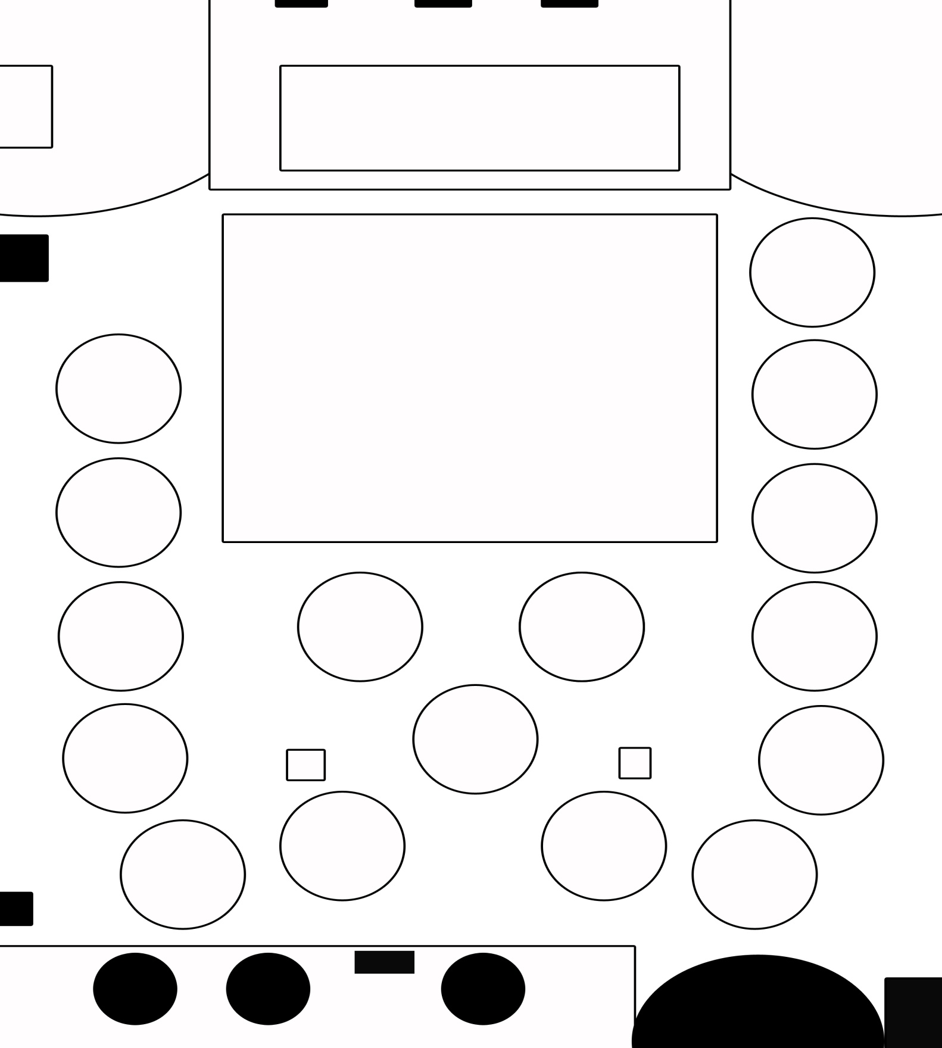

DANCE FLOOR

REAR
Official Contract
Agreement made this ______________ day of ________________________________ ________ , between The NEW
ROSEDALE HOUSE BANQUET HALL located at 18845 W. McNichols, Detroit, Michigan and the following:
Name_________________________________________Address___________________________________________
City State Zip___________________________________Email_____________________________________________
Phone Number______________________________________________Cell Number__________________________
Time:___________________ til __________________Date:_______________________________________________
Up to 5 Hours. There is an allotted 2 hours prior to event start time for décor. Additional time is at $50/Hr
It is agreed that The New Rosedale House will provide the following:

I,_________________________________________ ___________________________(NAME) have agreed to pay The
New Rosedale House the sum of $ _______________________________dollars for the following:
- Hall Rental $_________________________

- Food for __________guests. Number of expected guest (Set-up purposes only.)__________.

DINNER STYLE: _________________________________
MENU# 1 2 3

- Optional Services (See detailed sheet for explanation):
Disc Jockey - $250
Security (MANDATORY) - $275
House Digital Photographer (Mandatory)

If not at least two (2) licensed and professional security personnel are not provided the date of function. Security will be provided and charged. Name of security company/personel:

Photography Service - $495 Digital Photos
Audio Use - $75
Kitchen Rental (NO COOKING) - $75
Cabaret Usage/ Cooking of Kitchen - $200
Karaoke DJ - $300
Damage Deposit - $200 (Refundable - MANDATORY)
Security Deposit - $150 (Secure your date)
- REFUND ON DEPOSITS: A non-refundable deposit of $150.00 is required to hold the night in question. NO REFUND ON DEPOSITS. Deposits will be deducted from the total bill, additional payments are to be made as follows:
- Deposit of $150.00
- Half of bill refundable if within sixty (60) days prior to the affair
PAYMENT SCHEDULE:
60 Days Prior___________________By:__________Payment Due….Pd. Date_______________$
30 Days Prior___________________By: _________Payment Due….Pd. Date________________$
2 Weeks Prior_________._________By:_________Payment Due….Pd. Date________________$
10 Days Prior___________________By:__________Payment Due….Pd. Date_______________$
A NON NEGOTIABLE as far as the DAMAGE DEPOSIT RETURN is CONCERNED:
- There should be nothing damaged, cut, destroyed, dented, busted, stained, soiled, removed, missing, chipped or scratched. This includes but is not limited to the following: Missing furniture, tables, chairs, table cloths, curtains, podiums, plants, decorations (provided by NRH), utensils, appliances, any objects permanently or non-permanently affixed, mirrors, dishes, speakers, audio equipment, etc.

- EXITING: Party and guests are expected to vacate the property within thirty minutes of the time stated on the contract. For example, if end time is 12 midnight no one should be on the premises after 12:30a.m. For each additional fifteen minutes there is a $30 CHARGE/ 15 minutes. Five (5) hours maximum, plus one half hour cleaning time.
CLEANING: Guest who are utilizing the kitchen should also make sure the kitchen area is cleaned properly as well, including mopping of the floor, making sure drains are clear, sinks are cleaned and stoves. Clients may be subject to forfeiting their damage deposit . Confetti, silly string, and glitter is not allowed; if used at the event there will be a $95 charge for additional clean-up.
DAMAGE DEPOSIT: After a complete inspection of the property, damage deposits will be refunded accordingly in the form of a check. Service fees, damage fees will be removed from the security deposit. The amount will be based on the amount of damage if any. Within 3 – 5 business days of the event.
Signature acknowledging each term above:_________________________________________________
Total Due:________________________+ 200 Damage Deposit = ________________________________
Rental Agent – Rosedale House Representative
______________________________________________________Date_____________________________________

Client Date

The New Rosedale House
Affidavit of Liability
AGREEMENT for services made this__________day of______________________in the year of our lord 20____, between Anthony Mitchell (owner)/ agent _______________________, hereinafter referred to as the establishment and ________________________ (client) , hereinafter referred to as the undersigned; WITNESSETH: that the Establishment is hereby retained to contract_____________________________
services for the undersigned. The undersigned hereby hires the Establishment premises address known as _18845_W.McNichols in the country in WAYNE in the state of MICHIGAN to use and occupy for a strictly private affair.
We, the establishment ARE NOT RESPONSIBLE and shall HAVE NO LEGAL LIABILITY if Photos, Limo Service, Video Quality , food, linen, valet, coat check or any third party service contracted for the undersigned are not satisfactory. We are renting in an as-is condition. There will be no additional alterations unless previously discussed and agreed upon. We are not responsible for stolen, lost, n nor misplaced items, injuries, slip and falls, or any altercations deriving from guest disputes. In the event that any prevision of the agreement is held or determined invalid or unenforceable for any reason, the Establishment, The New Rosedale House, shall remain unaffected by such holding or determination . All third party services are provided for the convenience of the undersigned, and we do not indent in any way to define or describe the scope or intent of any provision of their agreement.
This agreement embodies the entire agreement and the understanding between the undersigned and the Establishment supersedes all added its use, unless otherwise expressly stated.
Sign:_______________________________________

Date:_______________________________________

Sign:_______________________________________

Date:_______________________________________

