COST SHEET OF EVENT
Event DATE______________________ Day_____________________
Time of Event:_______________________(5hrs)

HALL $_______________________________ $795 - $695- M-Fri,Sun - $495 Shower/Repast
FOOD $________________________________
SECURITY $_____________________________$250
VIDEO $_______________________________
PHOTOGRAPHY $________________________
DJ SERVICES $__________________________$250
Usage of Audio Equipment________________$75
TABLES $______________________________
There is an additional fee for table setting over 150
LINEN $________________________________$7/Table
CHAIR COVERS $__________________________$1.50
NAPKINS $_______________________________ .30/Napkin
DAMAGE DEPOSIT $______________________$200
TIP $_________________________________
ADDITIONALS $________________________

TOTAL$______________________________
Deposit $_____________________________
Balance Owed $_______________________
Pd By:___________________________________________________ Date_________________________

FACILITY SET-UP (Check boxes for tables that apply)
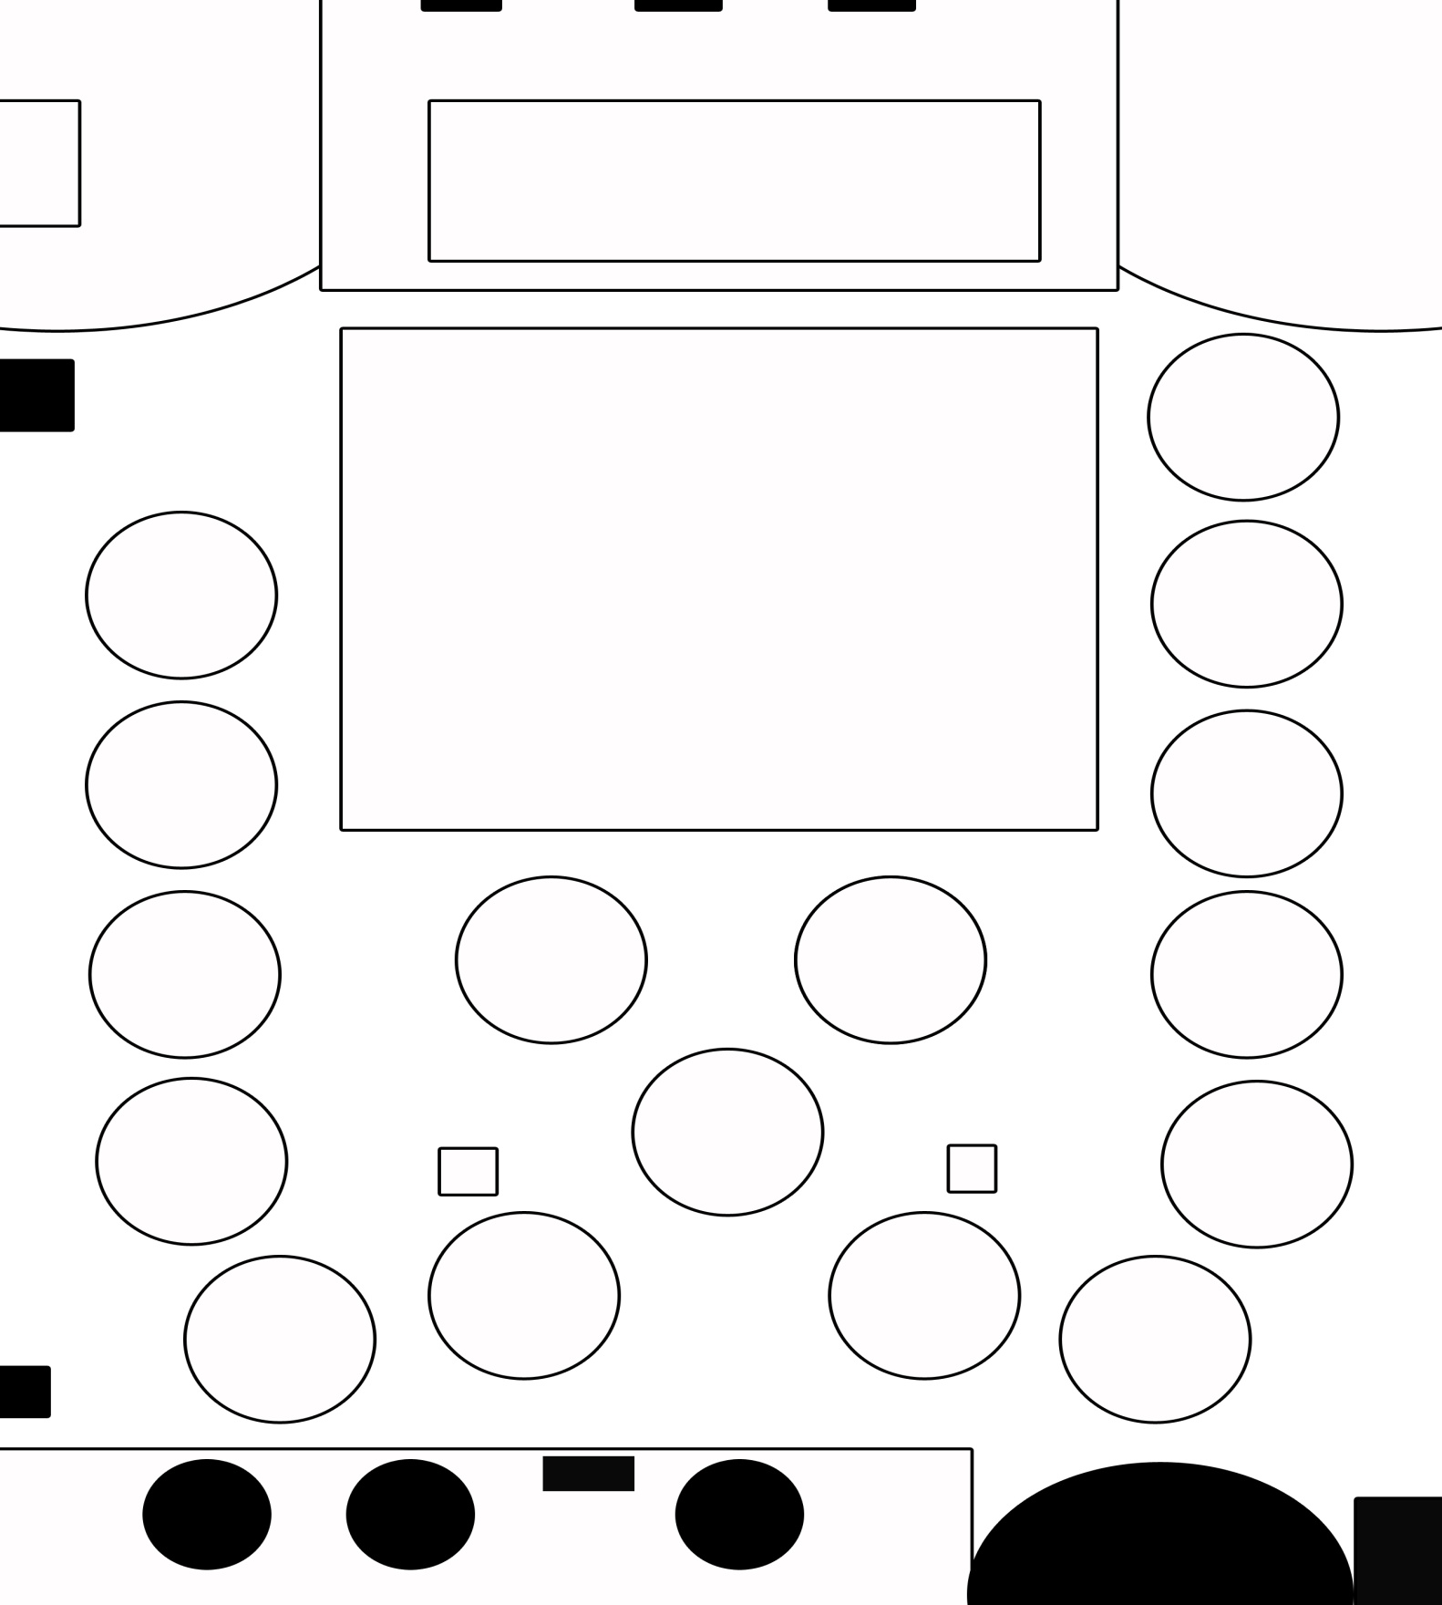

DANCE FLOOR

